SQL databases are table based databases whereas NoSQL databases are document based, key-value pairs, graph databases or wide-column stores.

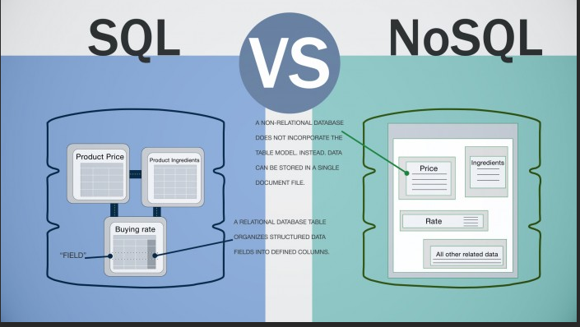

**SQL(Relational database)**

Structured Query Language

Very rigid schema

You spread data across multiple tables

Each table has a column or columns that provide quick navigation to a particular record

**NoSQL**

Not Only SQL

Not a rigid schema

Server software that provides database functionality

Examples Oracle Microsft SQL server MYSQL

**Database Functionality**

* Database
* Define the database structure
* Visual tools
* Enter, modify, and delete data
* Tools may be provided to import data from other sources
* Database security to provide an extra layer of protection beyond the network security alone
* Creates user names and passwords for database and control who can access specific data

Formulate queries based on the logical relationships among and the data

Sort search filter and perform other actions

**DML (Data Manipulation Language) analysts, report authors and programmers writing client apps**

* Views changes and manipulates data within a table. E.g. SELECT, UPDATE,INSERT ,DELETE

**Data Definition Language (DDL) db admin programmers**

* Creates and defines the database and objects within it

CREATE TABLE DROP TABLE

**Data Control Language (DCL) db admin programmers**

* Controls access to the data in a database

REVOKE GRANT

1. We licked on a preconfigured MySQL connection and that linked MySQL Workbench to my SQL server
2. Next under Server we clicked on import data to import a self-contained file work/pub1.sql
3. Thirdly, we created a new Scheme and named it pub1
4. Next we started the import process after naming our Scheme
5. After refreshing
6. Lastly, we went to the Schemas navigation pane and selected our table we just made pub1 and we have multiple tables already named. Customers, obsolete_tiles, Sales, sispers, and titles.

Databases can operate on a very small scale to large pens like companies

* **Data Analysts** usually manipulates data by directly typing Structured Query Language
* **Data administrator** Manages database

and tables by directly typing Structured Query

Language.Uses all SQL commands

* **App Developper:** embed SQL statements within app code so app can perform database tasks. Type code SQL, client app is published by dev to app store. Client app is installed on end users computer or app server
* **Client App user** Use the client app user interface to perform database tasks. No need to type SQL

Lab 1

We looked at each data (sales report, inventory, receipts, inventory form) and what the customers might want along with the stakeholders.